**NEO4J INSTALLATION ON WINDOWS**

STEP 1: Go to neo4j.com website.



STEP 2: Hover on GET STARTED and then select Neo4j Desktop



STEP 3. Click on Download Button.

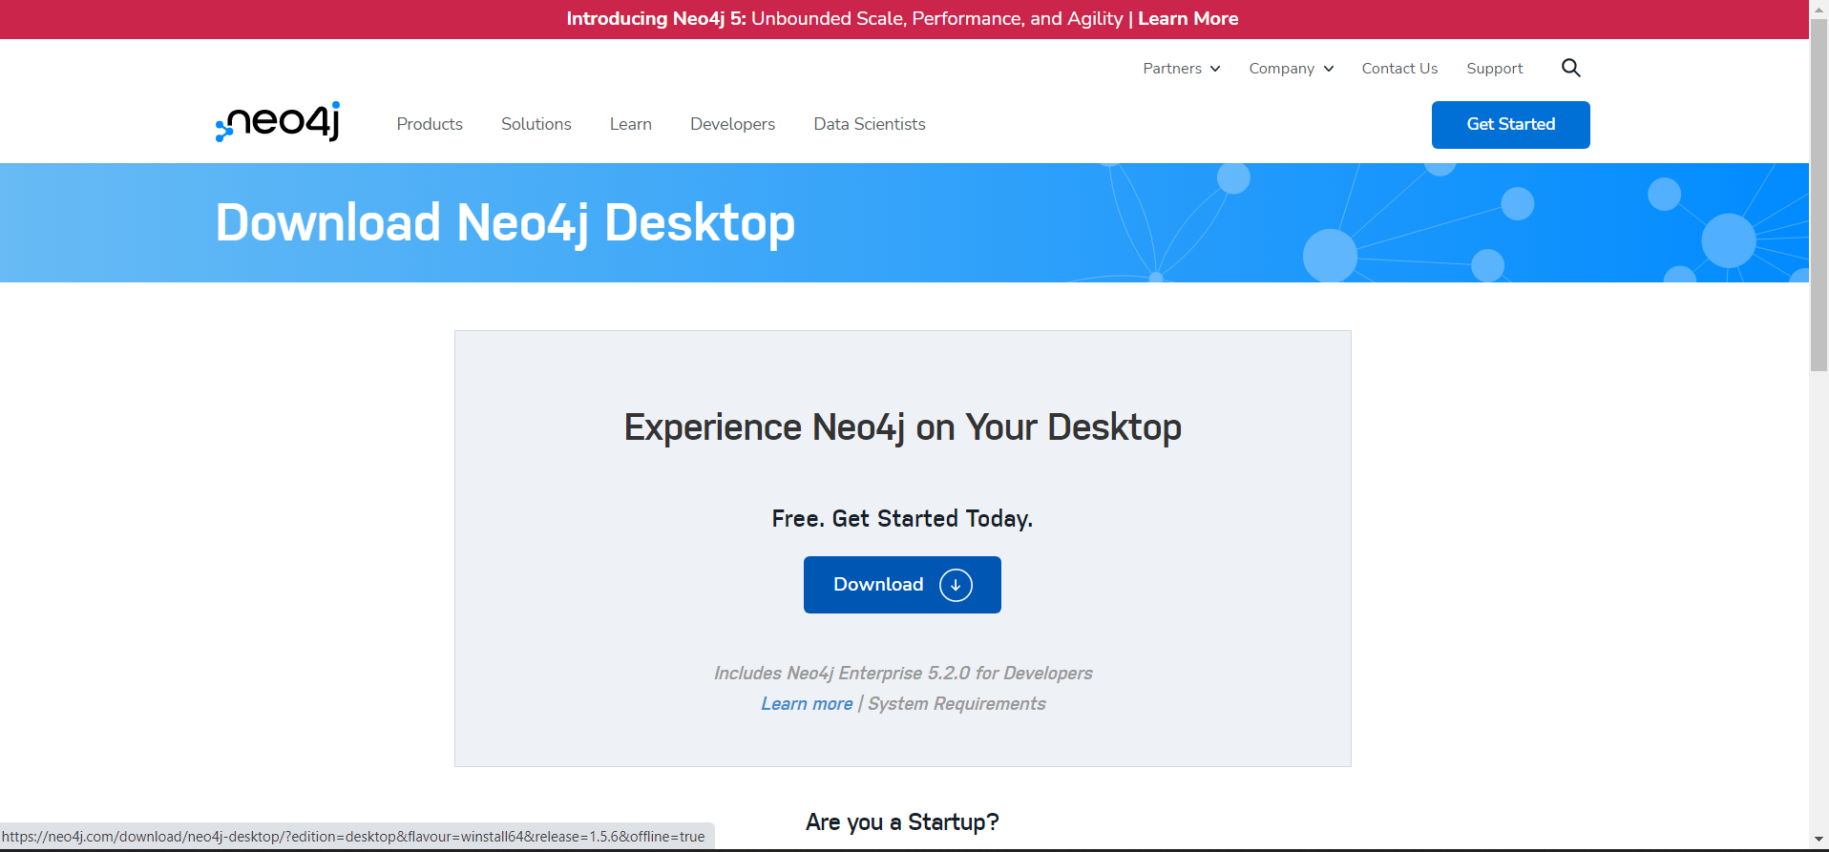

STEP 4: Enter necessary verifying information and hit DOWNLOAD DESKTOP button.

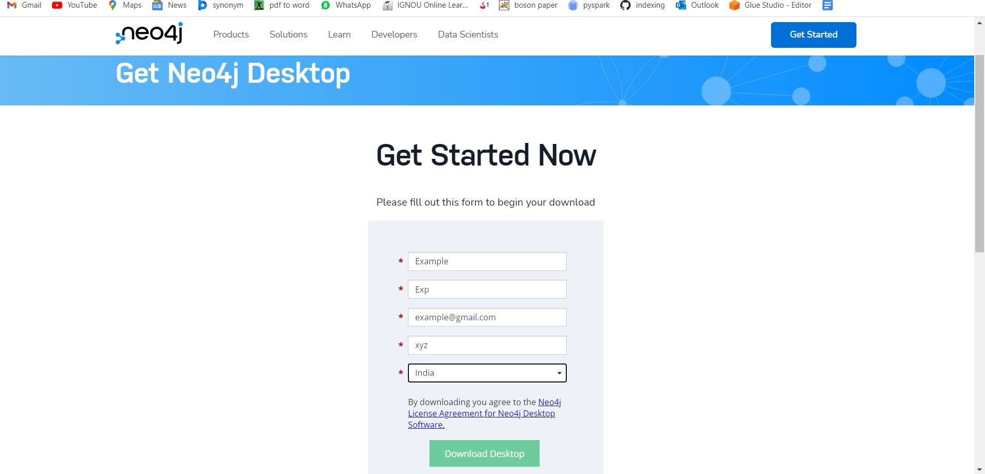

STEP 5: Downloading will Start.



STEP 6: **Copy Neo4j Desktop Activation Key.**

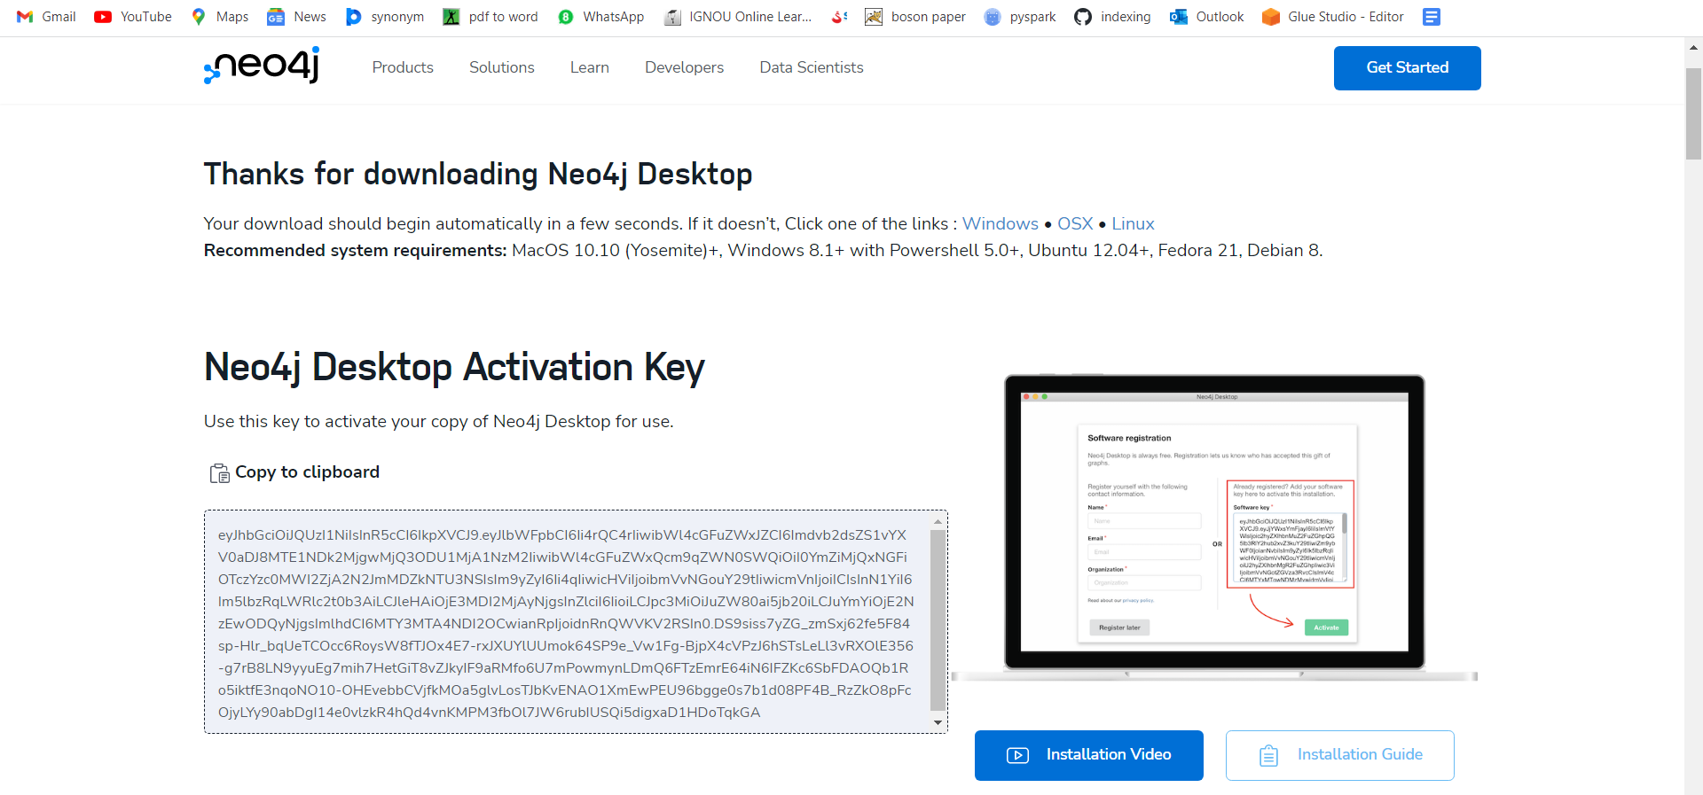

STEP 7: Now run the installer.

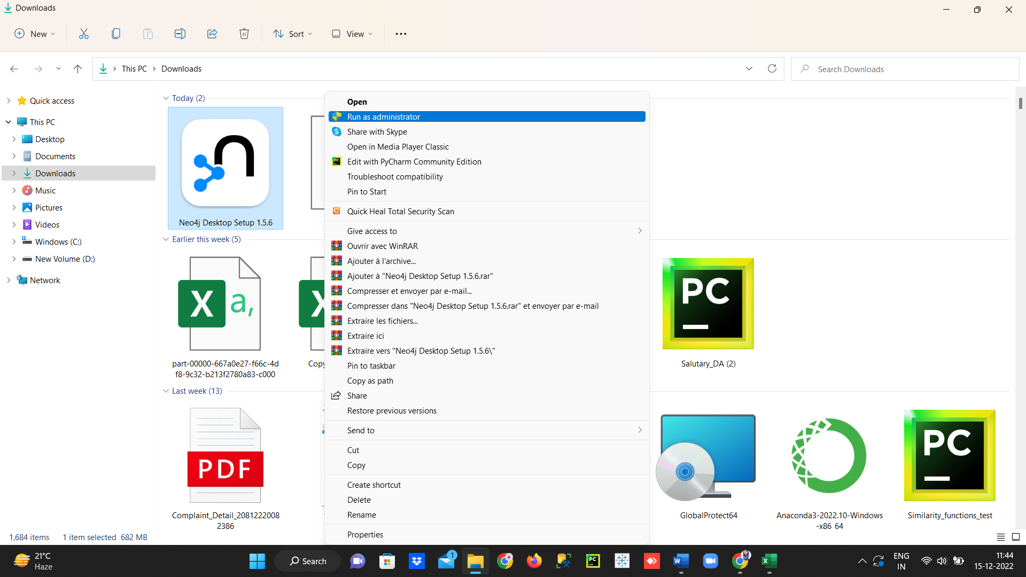

STEP 8: INSTALLATION



STEP 9: Select ‘Anyone Who Uses This Computer (all users)’ then ‘Next’.

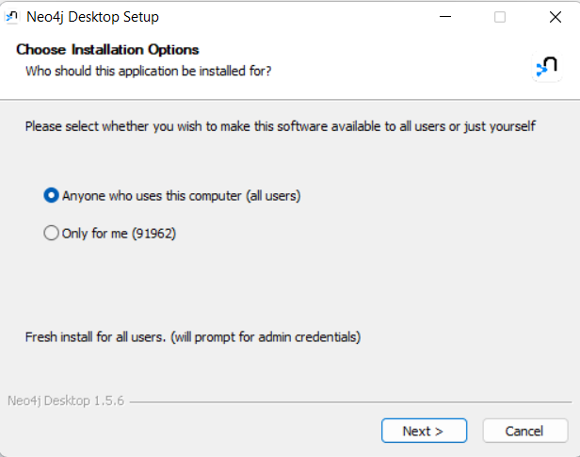

STEP 10: Proceed with the Default Location (advisable), Else enter your preferable location and ‘Install’.

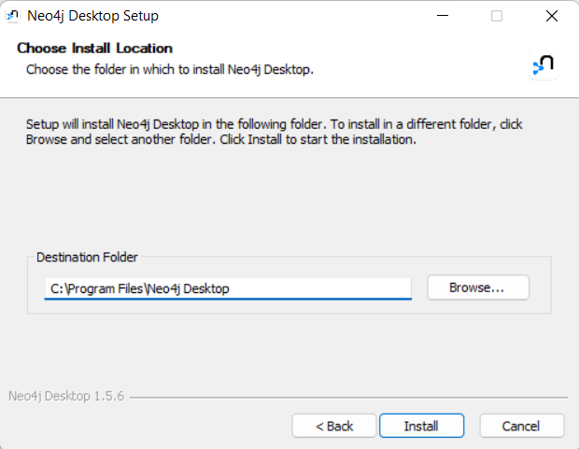

STEP 11: INSTALL

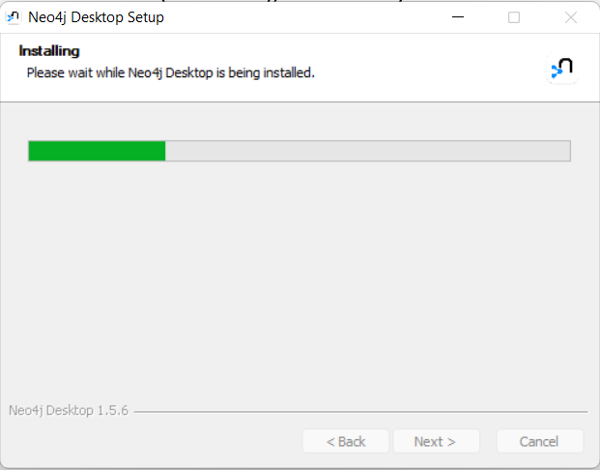

STEP 12: Finish

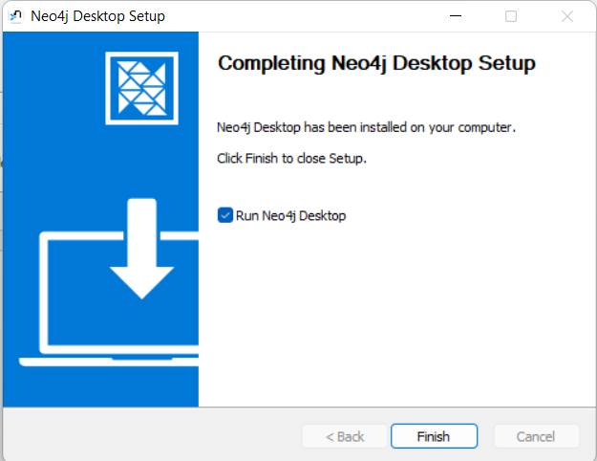

STEP 13: Open NEO4J on your Desktop and click on agree.

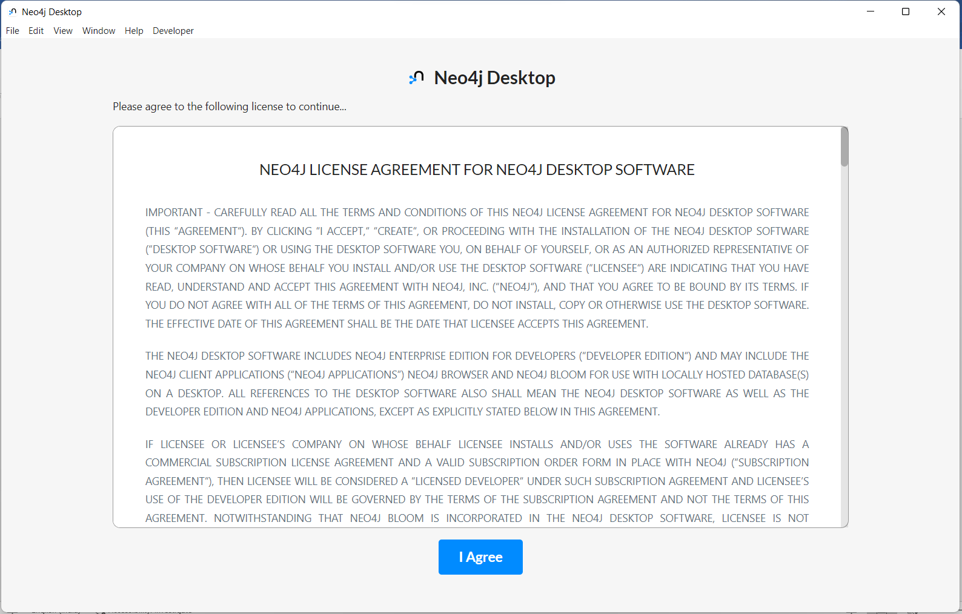

STEP 14: Select default address to save your data.



STEP 15: If you have a valid SOFTWARE KEY then enter else Provide the information for registration and proceed.

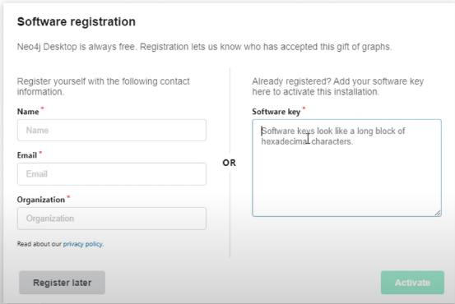

STEP 16: System Preparation

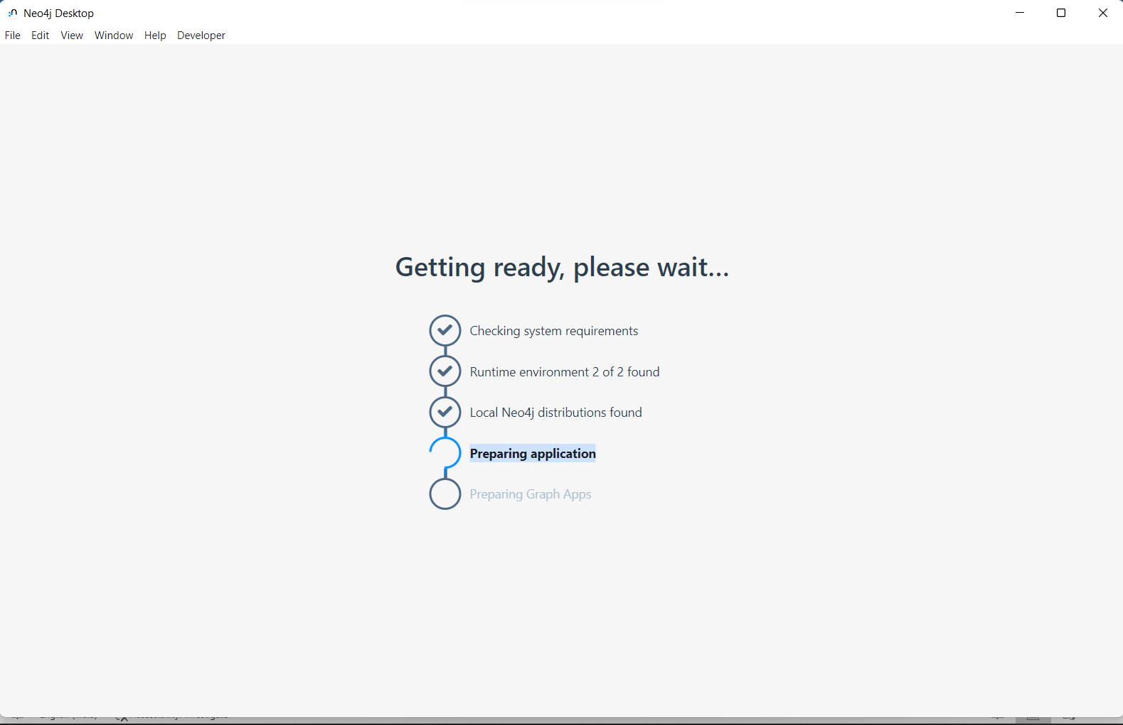

Here, we have NEO4J System to Work on.

